A mini project report on

Virtual Tourist Guide

By

Prathamesh Yadav, TED - 43

Vikas Dadhich, TED -03

Dishank Tiwari, TED - 40



Department of Computer Engineering

Shah and Anchor Kutchhi Engineering College, Chembur

University of Mumbai

2019-2020

# **Abstract**

Machine learning has been gaining momentum over last decades: self-driving cars, efficient web search, speech and image recognition. The successful results gradually propagate into our daily live. Machine learning is a class of artificial intelligence methods, which allows the computer to operate in a self-learning mode, without being explicitly programmed. It is a very interesting and complex topic, which could drive the future of technology.

Neural network is a machine learning algorithm, which is built on the principle of the organization and functioning of biological neural networks. This concept arose in an attempt to simulate the processes occurring in the brain by Warren McCulloch and Walter Pitts in 1943.

Neural networks consist of individual units called neurons. Neurons are located in a series of groups — layers (see figure allow). Neurons in each layer are connected to neurons of the next layer. Data comes from the input layer to the output layer along these compounds. Each individual node performs a simple mathematical calculation. Тhen it transmits its data to all the nodes it is connected to.

The last wave of neural networks came in connection with the increase in computing power and the accumulation of experience. That brought Deep learning, where technological structures of neural networks have become more complex and able to solve a wide range of tasks that could not be effectively solved before. Image classification is a prominent example.

Convolutional neural networks (CNN) is a special architecture of artificial neural networks, proposed by Yann LeCun in 1988. CNN uses some features of the visual cortex. One of the most popular uses of this architecture is image classification. For example Facebook uses CNN for automatic tagging algorithms, Amazon — for generating product recommendations and Google — for search through among users’ photos.

Let us consider the use of CNN for image classification in more detail. The main task of image classification is acceptance of the input image and the following definition of its class.

Instead of the image, the computer sees an array of pixels. For example, if image size is 300 x 300. In this case, the size of the array will be 300x300x3. Where 300 is width, next 300 is height and 3 is RGB channel values. The computer is assigned a value from 0 to 255 to each of these numbers. Тhis value describes the intensity of the pixel at each point.

To solve this problem the computer looks for the characteristics of the base level. In human understanding such characteristics are for example the trunk or large ears of an elephant. For the computer, these characteristics are boundaries or curvatures. And then through the groups of convolutional layers the computer constructs more abstract concepts.

In more detail, the image is passed through a series of convolutional, nonlinear, pooling layers and fully connected layers, and then generates the output.

I will use Python syntax for this project. As a framework I will use Keras, which is a high-level neural network API written in Python. But Keras can’t work by itself, it needs a backend for low-level operations. Thus I will install a dedicated software library — Google’s TensorFlow.

Contents

**Chapter 1: Introduction** 6

**Chapter 2: Literature Survey** 7

**Chapter 3: Problem Statement** 12

**Chapter 4: Project Design** 13

**a.** **System Block Diagram** 13

**b.** **Flow Chart** 13

**c.** **Algorithm** 14

**Chapter 5: Imlementation Details** 15

**5.1 Module and Description** 15

**5.2 Snapshot** 16

**Chapter 6: Result and Analysis** 21

**Chapter 7: Conclusion and Future Scope** 22

**1.** **Future Scope** 22

**2.** **Conclusion** 22

**3.** **References** 23

**4.** **Acknowledgements** 24

List of figures

|  |  |
| --- | --- |
| Figure | Page number |
| Figure 2.1 How a software developer creates a solution | 9 |
| Figure 2.2 How a data engineer develops a solution | 10 |
| Figure 2.3 Traditional Programming v/s Machine learning | 11 |
| Figure 4.1 System block diagram | 13 |
| Figure 4.2 Flow Chart | 13 |
| Figure 5.1 Login screen | 16 |
| Figure 5.2 Register screen | 17 |
| Figure 5.3 Camera screen | 19 |
| Figure 5.4 Results screen | 20 |

# **Chapter 1**

# **Introduction**

The image capturing and classification method is quite similar to that of Google lens in some functionality. The application is developed using JAVA as programming language and designed and coded in Android Studio.

The source image is uploaded by the user himself and then the image enters the image classification n procedure.

In the Android application the image will be saved and then sent to the server. The server then checks for the image in our database and provides the information about the monument or the place. The database is MySQL..

The image recognition process is done with the help of TensorFlow. We are using one of Google’s best image classifier library called ‘Inception’.

* 1. **Previous Related Work**

Traditionally, there are many tourism apps out there. These apps or websites are not user friendly at all. Almost none of them give an option of booking. Most of these applications are static applications and they are not maintained properly.

# **Chapter 2**

# **Literature Survey**

Tourists deliberately make plans that are highly structured and specific, so that they can take advantage of changing circumstances. Although the planning behaviour among travellers vary this is highly relevant for mobile travel applications. In the 21st century mobile applications for tourists have not only become relevant but the entire structure of their trip depends on the application. Tourist applications and web-sites have evolved a lot, our application is another step forward.

* 1. **Literature of Domains used**

The most crucial part of our application is the artificial intelligence in the domain of machine learning. The idea of the model processing the task on itself is extremely important in the era of modern technology. Artificial intelligence is a technology that is already impacting how users interact with, and are affected by the Internet. As machine learning is used more often in products and services, there are some significant considerations when it comes to user’s trust in the Internet. The training of the model may be a tiresome process but in the long run its totally worth it. The model needs to be trained for a long time, for e.g. the model may not give appropriate results after training 500 images, it may need 1000 images or may be 2000 images. The point is the trainer needs to have patience.

Machine learning is the idea that there are generic algorithms that can tell you something interesting about a set of data without you having to write any custom code specific to the problem. Instead of writing code, you feed data to the generic algorithm and it builds its own logic based on the data.

* + 1. **Advantages**

1. Efficient and adaptable.
2. Easy to use.
3. Less memory.
4. Also has a website.
   * 1. **Disadvantages**
5. Requires an active internet connection for booking.
   1. **Comparison with existing Systems**

There are many tourism applications and websites out there. Many of these models use a traditional model which is really hard to set up and code. The traditional model is not entirely outdated but as new technologies are being released everyday, the programmers need to use new and improved technology. Machine learning is used in our application which is highly efficient and reliable.

In traditional programming the user hard codes the behaviour of the program. In machine learning, the user leaves a lot of that to the machine to learn from data.

* + 1. **Traditional programming approach**

For any solution, the first task is the creation of the most suitable algorithm and writing the code. Thereafter, it is mandatory to set the input parameters and, in fact, if an implemented algorithm is ok it will produce the expected result.

**How a software developer creates a solution**

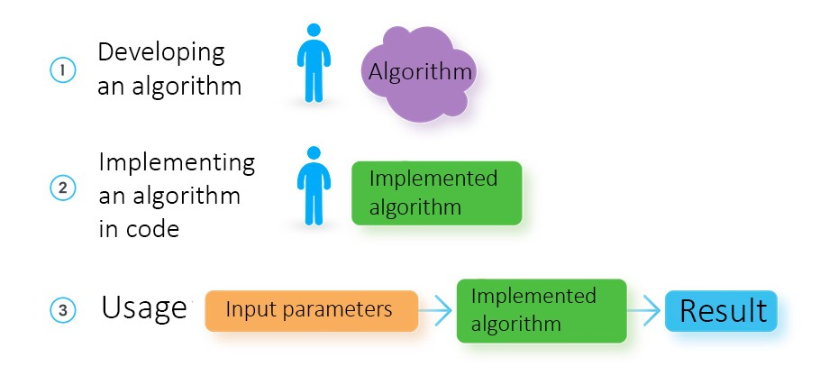

**Figure 2.1 How a software developer creates a solution**

However, when we need to predict something, we need to use an algorithm with a variety of input parameters. In case of prediction of the exchange rate, it’s mandatory to add such details like yesterday’s rate; external and internal economic changes in the country that issues the currency and more.

Consequently, we handcraft a solution that is able to accept a set of parameters and, based on the input data, predict a new exchange rate.

We also need to add a thousand and hundreds of parameters, whereas their limited set allows building a very basic and unscalable model. So yes, for any person is troublesome to work with such massive data arrays.

* + 1. **Machine learning approach**

To solve the same problem using ML-methods, data engineers use a totally different procedure. Instead of developing an algorithm on its own, they need to collect an array of historical data that will be used for semi-automatic model building.

Following managing a satisfactory set of data, the data engineer loads it into already tailored ML-algorithms. The result is a model that can predict a new result, receiving new data as input.

**How a data engineer develops a solution using machine learning**

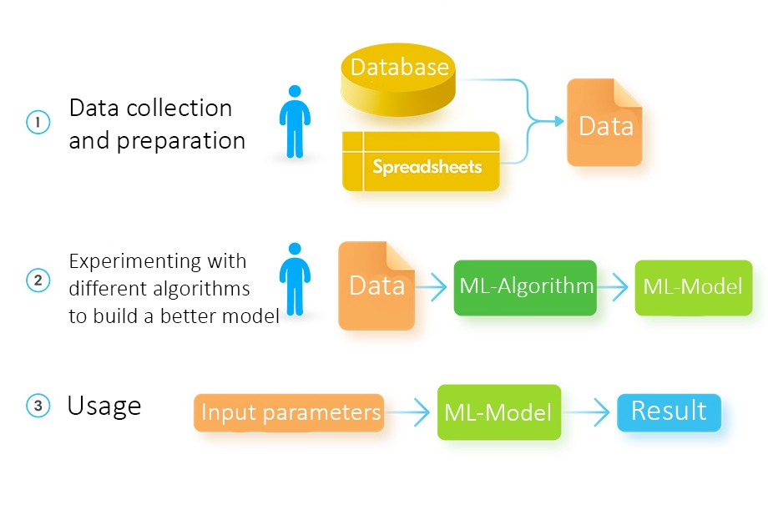

**Figure 2.2 How a data engineer develops a solution**

A distinctive feature of ML is there is no need to build a model. This complicated yet meaningful responsibility is executed by ML-algorithms, and ML expert will only add just a minor edit to this.

Another significant difference between ML and Programming is determined by the number of input parameters that the model is capable of processing. For an accurate prediction, you have to add thousands of parameters and do it with high accuracy, as every bit will affect the final result. A human being a priori cannot build an algorithm that will use all those details in a reasonable way.

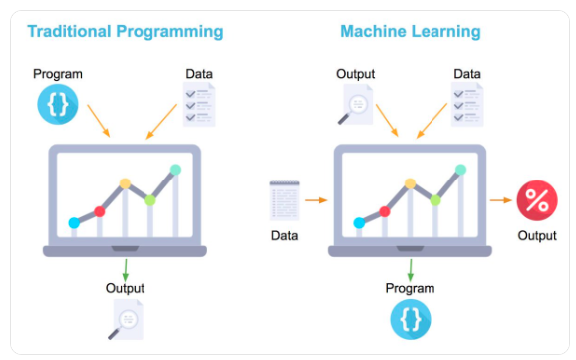

**Figure 2.3 Traditional Programming v/s Machine learning**

However, for ML, there are no such restrictions. As long as you have enough processing power and memory, you can use as many input parameters as you see fit. Undoubtedly, this fact makes ML be so powerful and widespread nowadays.

# **Chapter 3**

# **Problem Statement**

The main objective of project is to build an Android application for the users on which they can find information about various monuments in their own language i.e. they can correctly classify the respective place/monument. Many times due to lack of guides or less information tourist don’t get proper information. Also sometimes they get trouble to find nearby famous places to visits.

It works as a tourist guide virtually.

# **Chapter 4**

# **Project Design**

## **System Block Diagram**

**Figure 4.1 System block diagram**

## **Flow Chart**

Illustrated below is the flowchart of convolution network for image classification.

**Figure 4.2 Flow chart**

## **Algorithm**

The following models are implemented in machine learning:

1. Construction
2. Training
3. Testing
4. Evaluation

**Algorithm:**

1. begin with its object: model = Sequential()
2. then consist of layers with their types: model.add(type_of_layer())
3. after adding a sufficient number of layers the model is compiled. At this moment Keras communicates with TensorFlow for construction of the model.
4. During model compilation it is important to write a loss function and an optimizer algorithm. It looks like: model.comile(loss= ‘name_of_loss_function’, optimizer= ‘name_of_opimazer_alg’ ) The loss function shows the accuracy of each prediction made by the model.

# **Chapter 5**

# **Implementation Details**

## **5.1 Module and Description**

The solution comprises of the following modules.

1. User registration

User need to register by filling up basic registration details and need to create a login id and password.

1. Login

User can login into his/her account by providing valid login credentials.

1. Take a picture

Use the camera to take the picture.

1. Select from gallery

The user can also select the existing picture from the gallery.

## **5.2 Snapshot**

1. **Login Screen**

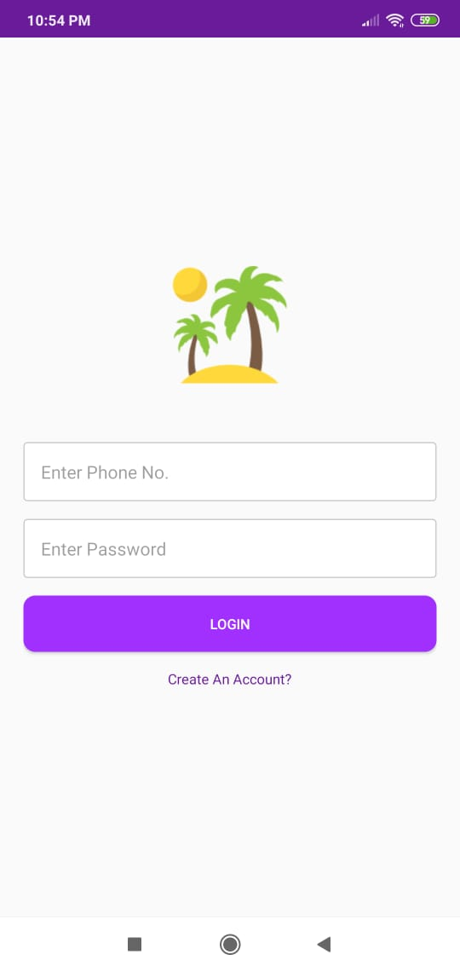

**Figure 5.1 Login screen**

This screen appears after installing the app.

1. **Register Screen**

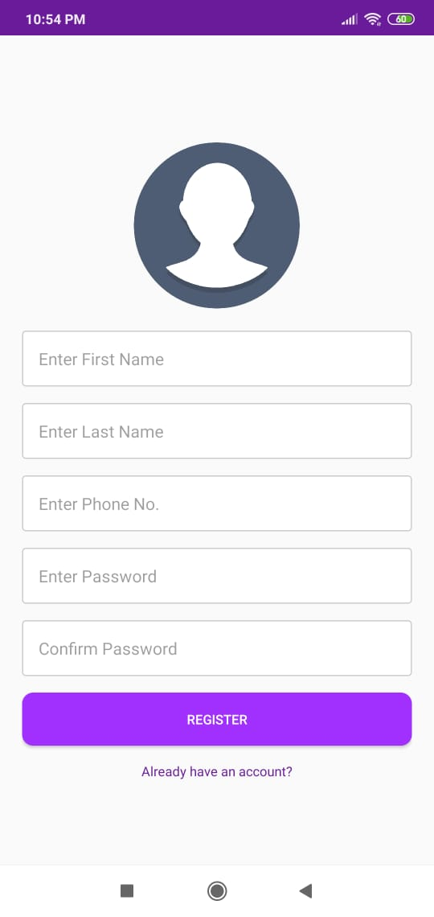

**Figure 5.2 Register screen**

1. **Home Screen**

The user enters the necessary information for registering. Next, the user uses the credentials entered for logging in the app.



1. **Camera screen**

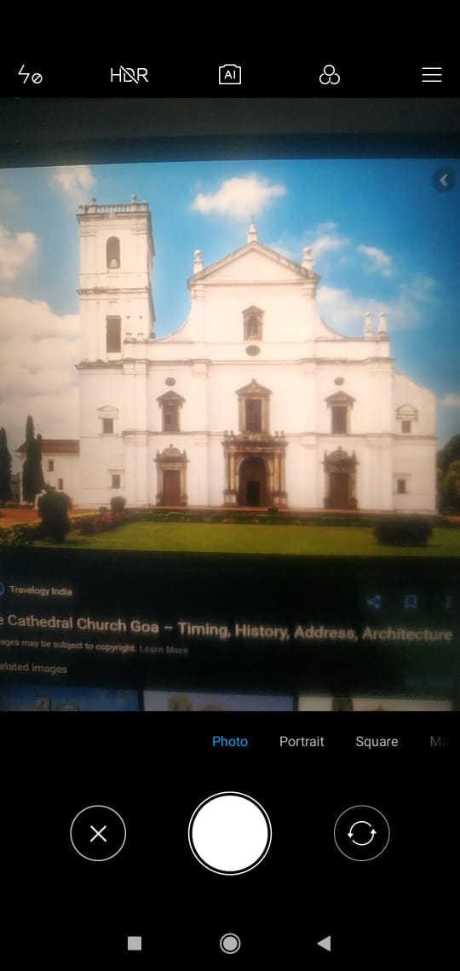

**Figure 5.3 Camera screen**

Click the photo with the camera.

1. **Result screen**

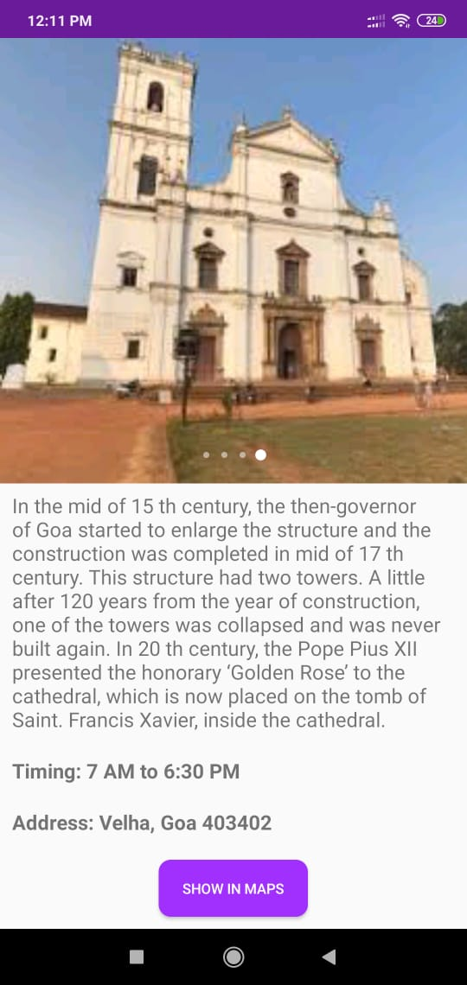

**Figure 5.4 Results screen**

The server gives the result back.

# **Chapter 6**

# **Result and Analysis**

With this application the user can recognize well-known landmarks in an image. When the user passes an image to the API, he gets the landmarks that were recognized in it. The application works with the help of TensorFlow. The user snaps the photo with the help of the mobile camera and then the classification process begins. The model is trained with 1500 images The algorithm compares the user image with the database images, when the user image is classified the server gives back the information for that image.

The first job was to download the images for training. After downloading the initial set of images, we observed that some URLs were broken and many images were corrupt images. Downloading the trained images took about 28 hours, and downloading the training images took about 12 hours.

Although the algorithm does pass to classify real monuments from false images. If the user enters a false image try again alert message is given to the user.

# **Chapter 7**

# **Conclusion and Future Scope**

## **Future Scope**

The scope of tourism applications and digital world is very vast. In today’s world no tourist uses a paid guide to show them around the respective monument.

For now our application is used for monument or landmark recognition, but in the future version we plan to include a very high profiled booking system which can help the users to plan their trips ahead of time.

The future version will include a system to rent cars, book hotels and show some of the other trendy destinations.

This is an android application and it will not be available in IOS. We will provide updates as possible.

## **Conclusion**

The app is an android application used for image classification. The user has to capture the image with his camera inside the app(there is a camera button on the user dashboard) and then the image is classified by TensorFlow and then the landmark information is given back to the user.

## **References**

1. http://firebase.com/docs/ml-kit/landmark-recognition.
2. Y. Li, J. H. Lim, and H. Goh, “Cascaded classification with optimal candidate selection for effective place recognition”, Proc. IEEE Conf. Multimedia, Hannover, Germany, pp.1493-1496, 2008.
3. A. Qamra and E. Y. Chang, “Scalable landmark recognition using EXTENT”, Multimedia Tools and Applications, vol.38, pp.187-208, 2008.
4. J. Zhang, M. Marszalek, S. Lazebnik, and C. Schmid, “Local features and kernels for classiﬁcation of texture and object categories: A comprehensivestudy,”inIEEEConf.ComputerVisionandPatternRecognition Workshop, 2006, pp. 13–13.
5. B. Girod et al., “Mobile visual search,” IEEE Signal Process. Mag., vol. 28, no. 4, pp. 61–76, 2011.
6. <https://wikipedio.org/wiki/TensorFlow>.

## **Acknowledgements**

We are pleased to present “A Tourist Guide” project and take this opportunity to express our profound gratitude to all those people who helped us in completion of this project.

We would also like to thank her for providing us with all proper facilities and support as the project co-coordinator. We would like to thank her for support, patience and faith in our capabilities and for giving us flexibility in terms of working and reporting schedules.

We are extremely grateful to the teaching staff of our college for their immense support.

We would like to thank all our friends and classmates who have helped us a lot.

Sincerely,

Dishank Tiwari

Prathamesh Yadav

Vikas Dadhich